HOW TO TAKE APPOINTMENT FOR SUBMISSION OF APPLICATION FOR PASSPORT

Please fill up the Application, online, and register online. Please visit our website: ww.cgimilan.gov.in. You can see the opening page as under:
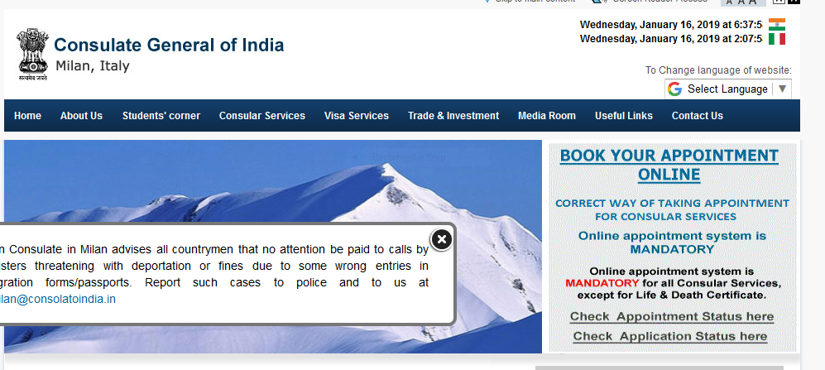
Please Click on the “BOOK YOUR APPOINTMENT ONLINE” button. It will you take you to a screen as under :

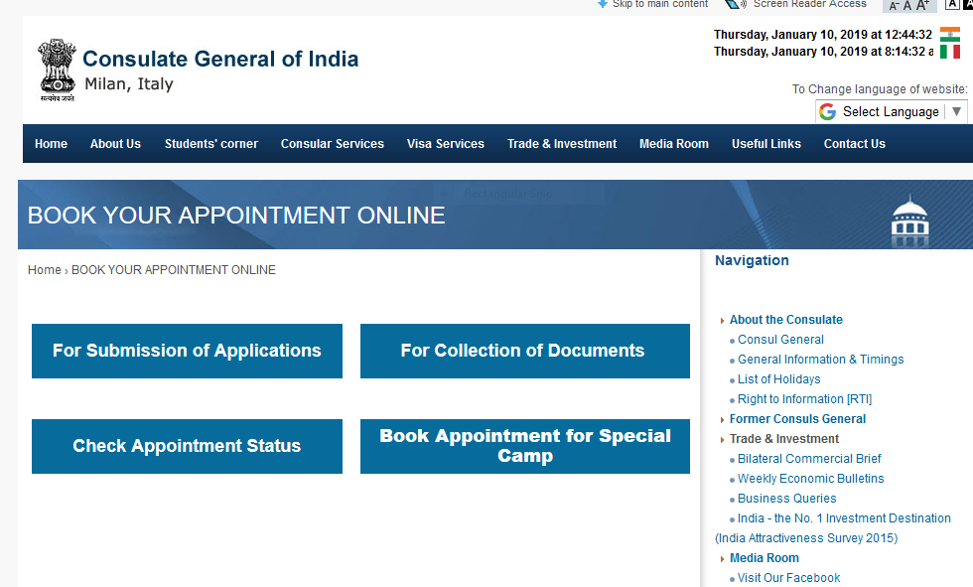
Once you click on the Button “for Submission of Applications”, the next screen will appear as under : 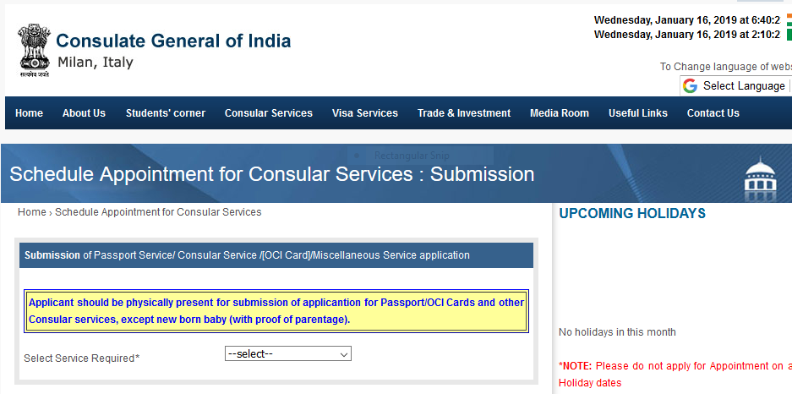

Click on the Service you require, i.e., “Passport Service” and it will take you to another screen, as under :
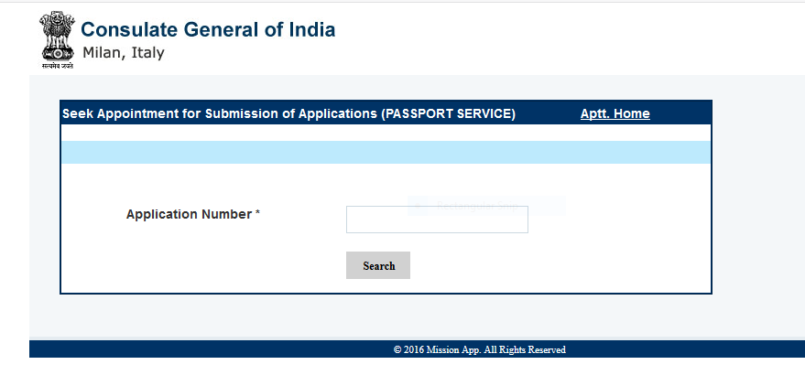
Please enter your Application Number, which is the WEBFILE NUMBER (ITAMP……) created after completion of your application form for Passport. After entering the Application Number, click on the SEARCH button, it will take you to the next screen, as under;

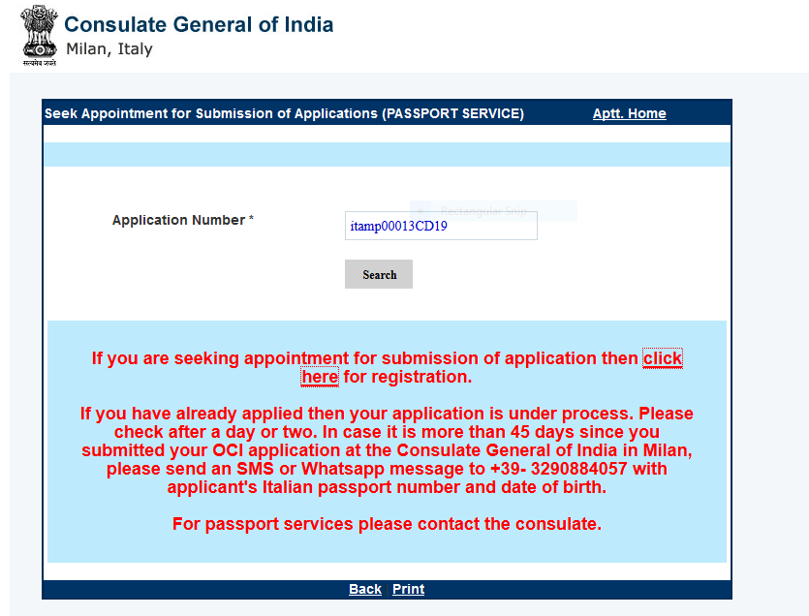

Click on the button “Click here for registration”. Once you click on the button, it will take you to another screen, as under :

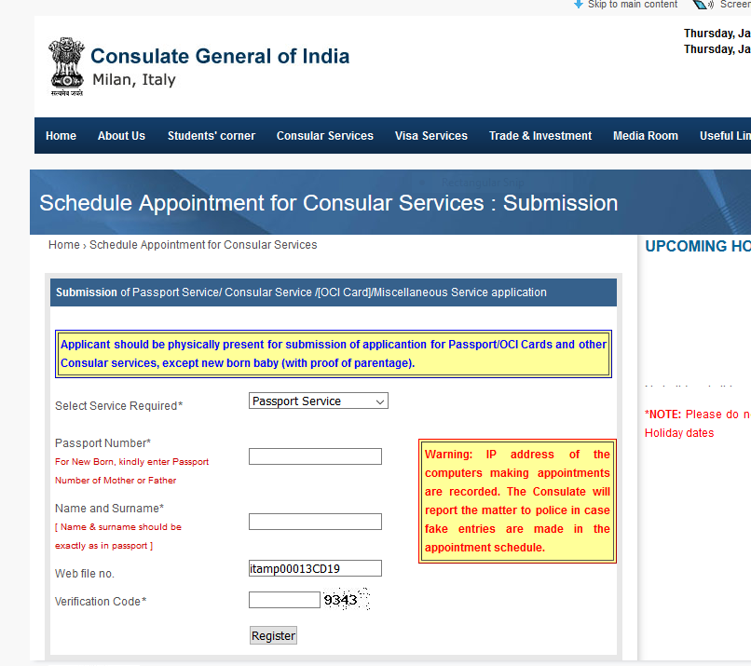

Please enter your Passport Number and your name followed by surname. Thereafter, please enter the Verification Code and click on the button “Register”. The next screen will appear, as under :

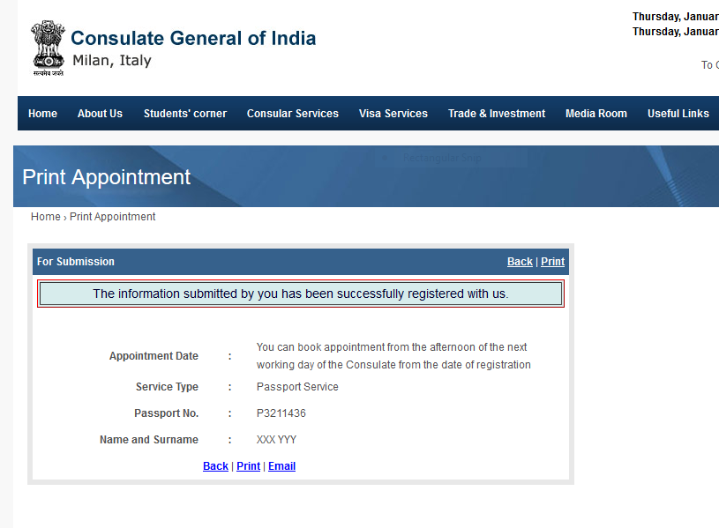
You will be able to take appointment from the afternoon of the next working day of the Consulate from the date of registration.

When you click on the BOOK YOUR APPOINTMENT ONLINE, next day afternoon, for taking appointment, the screen will appear as under :

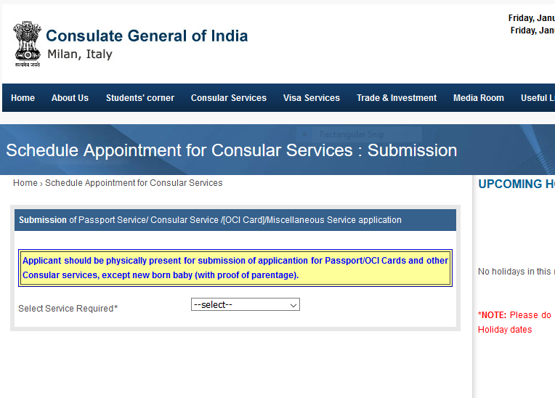

Once you select Passport Service, the screen will appear as under :
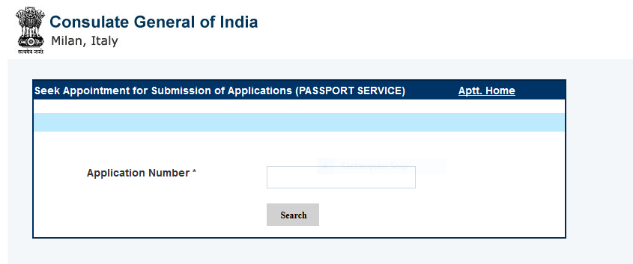

Please enter the Application Number (ITAMP……) and the screen will appear as under :
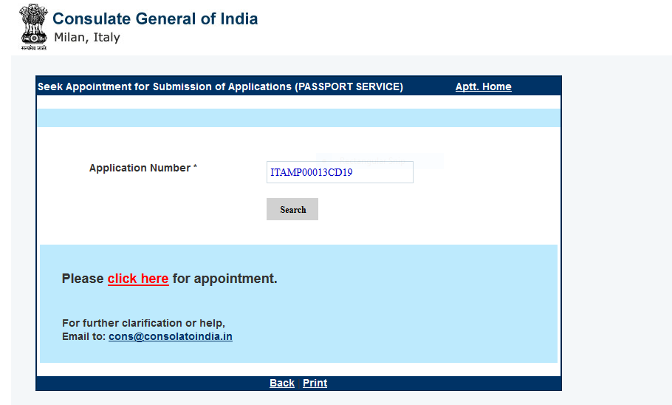

Please click on the button “CLICK HERE for appointment”. It will take you to another screen as under :

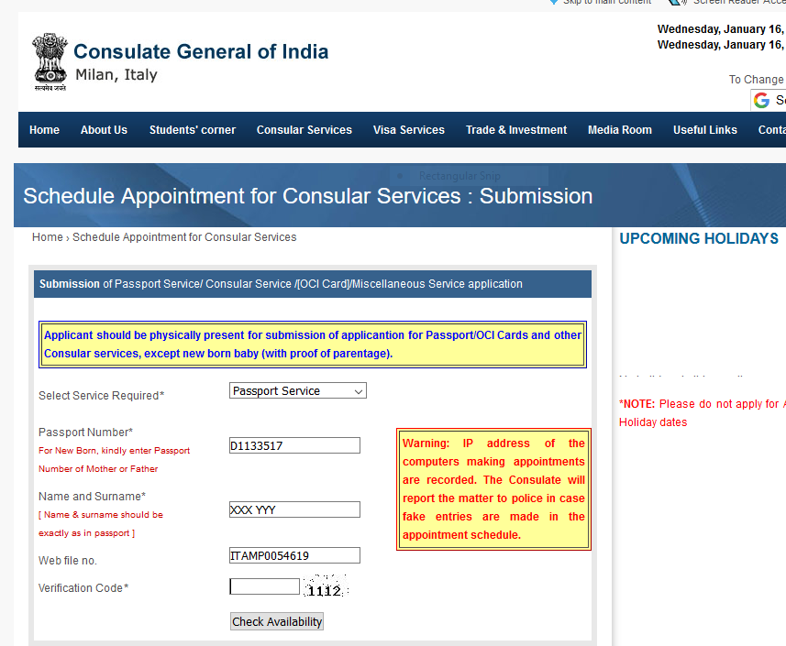

Please enter the Verification Code and click on “CHECK AVAILABILITY”. It will take you to another screen as under:
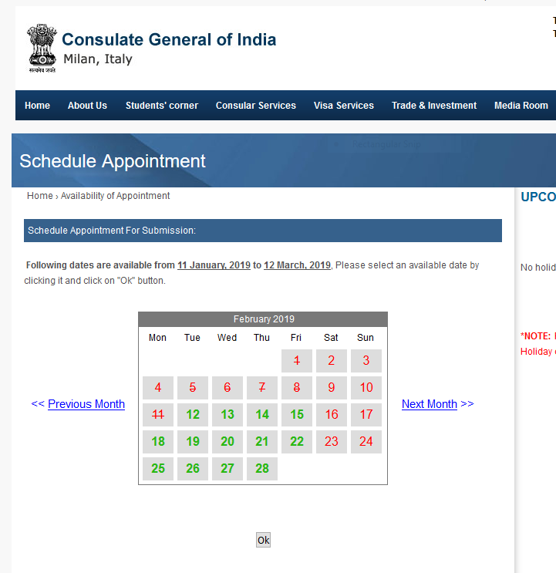

Available dates are shown in GREEN COLOUR. If no dates are available, the dates will be displayed in RED colour. If no date is available in the particular month, you can click on the button “Next Month” shown on the right side of the calendar. You can choose the date as per your convenience and click on the date.

Once you click on the chosen DATE, please click on the “OK” button and it will take you to the next screen as under :

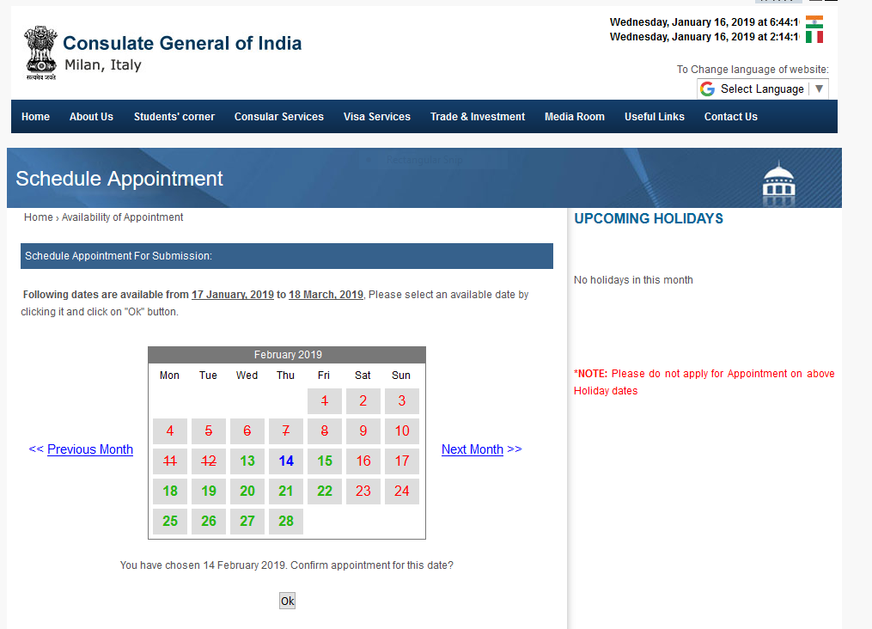

As can be seen, the date you selected turns into BLUE. Please click on “OK” button and your appointment is booked for the day you selected and the confirmation will be displayed as under :

